CANOPY BULK DENSITY PLOT
PLOT ID: __________________ DATE_______________
RECORDER(S): _________________________________________________
LAT. _____°_____’_______”_____ LONG. ______°______’______”_____
TREE SPEICIES: _________________________________________________
TREE HEIGHT: _____________ft. CANOPY BASE RADIUS: ______________ft.
CANOPY BASE HEIGHT: _____________ft. CROWN MASS: _____________lbs
DBH: _____________________ PHOTO ID: ___________________________
NOTES: ________________________________________________________
_______________________________________________________________

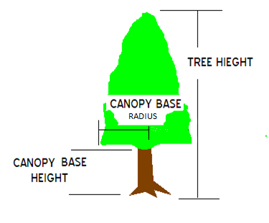

DATE ENTERED: ___/___/______ ENTERED BY: ________________

CANOPY BULK DENSITY PLOT
PLOT ID: __________________ DATE_______________
RECORDER(S): _________________________________________________
LAT. _____°_____’_______”_____ LONG. ______°______’______”_____
TREE SPEICIES: _________________________________________________
TREE HEIGHT: _____________ft. CANOPY BASE RADIUS: ______________ft.
CANOPY BASE HEIGHT: _____________ft. CROWN MASS: _____________lbs
DBH: _____________________ PHOTO ID: ___________________________
NOTES: ________________________________________________________
_______________________________________________________________

DATE ENTERED: ___/___/______ ENTERED BY: ________________

